EMPLOYMENT EQUITY
AMENDMENT ACT WORKSHOP
REPORT 19TH JUNE 2023

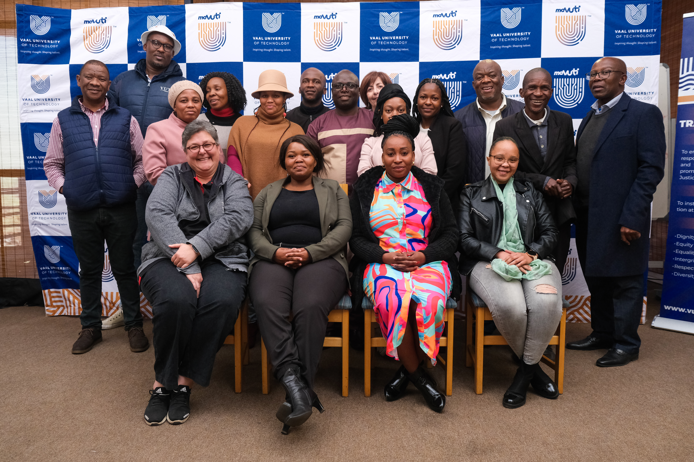
PHOTO CRED: PETER MASELA

- Introduction

The Vaal University of Technology hosted an Employment Equity training workshop for a group of 20 VUT staff members on the 19th of June 2023, at Sisonke Restaurant in Vanderbiljpark. The workshop was organized by the Social Justice and Transformation Unit and facilitated by Naomi Brehm from the company called Prospen Africa. The facilitator and the attendees arrived around 08h00 for breakfast and registration.

- Opening Remarks

This was done by the Director: SJT, Mr. G Mvalo, and he mentioned that the workshop was intended to ensure that the employment environment is equitable, fair, and transparent. He indicated that VUT is one of the designated employers and is required in terms of the law to become substantively compliant as a university so that it will be held accountable for ensuring the employment is equitable as possible. Mr. Mvalo also acknowledged the presence of Prof. Justus Wesonga, a Research Professor from Kenya, who honored the workshop with his presence.

- Background of Facilitator (Ms. Naomi Brehm)
Ms. Naomi Brehm has worked as an independent consultant since 1999 during which time she have been a Director of Pivotal Solutions (Pty) Ltd, a generalist HR Consultancy, and a member of EVA Solutions. She is currently the CEO of EVA Solutions.
Her projects have included the compilation and implementation of Social & Labour Plans for the mining industry. In addition, she has focused on designing and implementing Strategic Human Resource Management Systems, general Human Resource Management systems, performance management systems, job evaluation, and selection and recruitment. She has been extensively involved with several companies in setting up their Human Resource policies and procedures and in designing and implementing Employment Equity and Skills Development Structures.
4. The purpose of the EE Workshop
The purpose of the workshop was to inform the staff members of VUT about the new amendments to the Employment Equity Act, no 55 of 1998.

- EEAA Workshop

Ms. Brehm started facilitating the training from 09h10 until 11h10, thereafter there was a tea break from 11:10- 11:25. She continued with the training until 14:00.

The Course benefits for the workshop were:

- Understand the background and history of discrimination in South Africa.
- Demonstrating knowledge and understanding of diversity, different cultures and values.
- Delegates will be able to describe transformation legislation.
- Understand the Employment Equity Act, including the recent amendments and their relevance to companies.
- Understand the rights, functions, and responsibilities of Employment Equity Consultation Committees.
- Know how to draw up an Employment plan, Implement, monitor, evaluate and report on employment plan implementations.

- Attendees

  - The number of attendees in of terms of race, gender, and nationality,

Table 1: Attendees in terms of gender
Male | Female
7 | 10

Table 2: Attendees in terms of race
Race | Total
African | 16
White | 1

Table 3: Attendees in terms of Nationality
South African | Non-South African
16 | 1

- Vote of Thanks

Mr. V Mashilwane, the EE Practitioner, gave a vote of thanks after the presentation. He was thankful to Ms. Brehm for facilitating the training distinctively. He mentioned that her EEAA presentation was insightful and educational. He honored Mr. Mvalo’s presence and for sharing his expertise during the session.

Finally, he expressed his gratitude to all the attendees and acknowledged the Campus TV crew for their participation in the workshop. He advised his fellow workers to check the SJT website for the services rendered.

